Neuron nucleus is in the cell body (soma)

The soma is also the location of the endoplasmic reticulum and ribosomes.

dendrites are appendages emanating directly from the soma that receive incoming messages from other cells.

axon hillock integrates the incoming inhibitory or excitatory signals to initiate an action potential.

action potentials involving the axon hillock transmit electrical impulses down the axon.

myelin acts as an insulator and increases the speed of conduction and prevents signal loss or crossing of signals.

In the Peripheral nervous system (PNS), myelin is made by Schwann cells.

In the central nervous system (CNS) myelin is made by oligodendrocytes.

nodes of Ranvier - exposed areas of axon membrane critical for signal conduction.

Nerve terminal- flattened structure maximizing neurotransmission between neurons

Neurotransmitter- chemicals that transmit information between neurons

Axons carry neural signals AWAY from the soma.

Dendrites carry signals toward the soma.

the amygdala is a neural structure that is part of the limbic system and is involved in emotion and learning (especially fear-based conditioning)  
  
the hippocampus is a neural structure that is part of the limbic system and is involved in memory formation, learning, and recall.   
  
the motor cortex sends motor commands from the brain to the muscles of the body.

Parkinson disease is a progressive neurodegenerative disease caused by death of dopaminergic neurons in the basal ganglia (substantia nigra), located in the midbrain (mesencephalon).   
  
Depression symptoms:

Feelings of sadness, hopelessness, or emptiness.   
lack of interest or pleasure.   
changes in appetite (eating more or less)

Changes in sleep (sleeping more or less)

Fatigue

Low Self-Worth or guilt

Cognitive difficulties

Thoughts about death or suicidal ideation

serotonin reuptake inhibitors (SSRI) block reuptake of serotonin from synaptic cleft into presynaptic neuron.   
  
monoamine oxidase inhibitors decrease breakdown of monoamines (eg serotonin) by inhibiting monoamine oxidase.  
  
Psychoanalytic theory: major defense mechanisms (incomplete list)  
  
denial = inability or refusal to recognize unacceptable thoughts/ behaviors   
projection = Attributing unacceptable thoughts/ behaviors to someone or something else   
rationalization = making excuses for unacceptable thoughts/ behaviors   
regression = behaving as if much younger to avoid unacceptable thoughts/ behaviors  
repression = blocking unacceptable thoughts/ behaviors from consciousness   
displacement = taking out unacceptable thoughts / behaviors on a safe target  
sublimation = transforming unacceptable thoughts/ behaviors into acceptable thoughts / behaviors  
reaction formation = behaving in a manner opposite unacceptable thoughts/ behaviors

take away: psychoanalytic theory suggests that ego defense mechanism are a method of dealing with unacceptable thoughts and behaviors that cause anxiety.   
  
Attitude   
3 main parts:   
affective component how a person “feels” about something, positive or negative emotions.

Cognitive component is a person’s “beliefs and opinions” about something. Eg a person thinks political candidate A is well suited to hold office.   
behavioral component: how a person “acts” towards something. Eg voting or standing up for something.   
  
expectancy theory of motivation proposes that motivation results from expectancy (believing one is capable of achieving an outcome), instrumentality (believing one has control over the outcome), and valence ( believing the outcome is desirable).

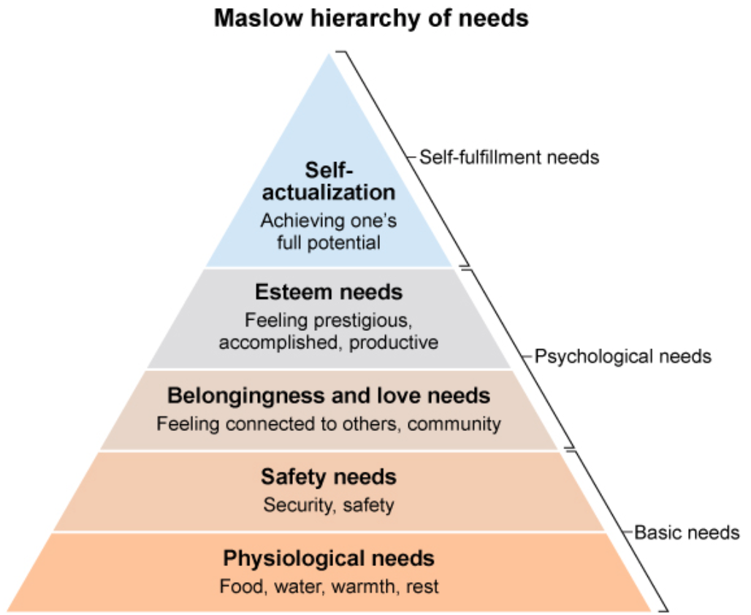  
  
drive-reduction theory proposes that motivation is a result of a disruption of homeostasis which generates a biological need. The biological need generates a drive to fulfills that need, which prompts action.   
  
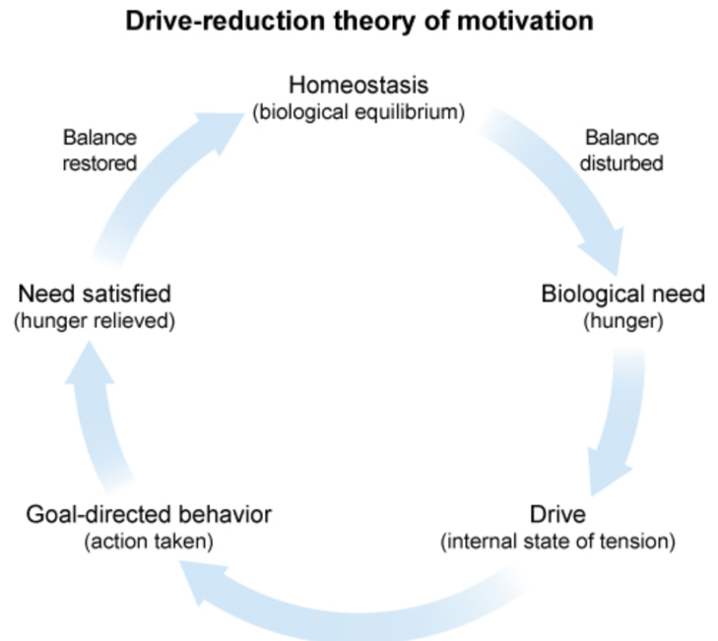  
  
  
Stats:   
correlation coefficient (r-value) close to 1 indicates a strong linear relationship between variables.   
positive correlations reflect scores that more in the same direction (both increase or both decrease), while negative correlations reflect scores that move in opposite directions (on increases while the other decreases).

learned helplessness describes feelings of extreme powerlessness along a perceived lack of control often from the result of a series of failures or trauma. When an individual start to feel that their efforts are futile and stops trying altogether, learned helplessness is achieved.  
  
  
learned helplessness is tied to low self-efficacy (personal beliefs about one’s abilities) and external locus of control (personal beliefs whether one can influence the outcome of a situation).

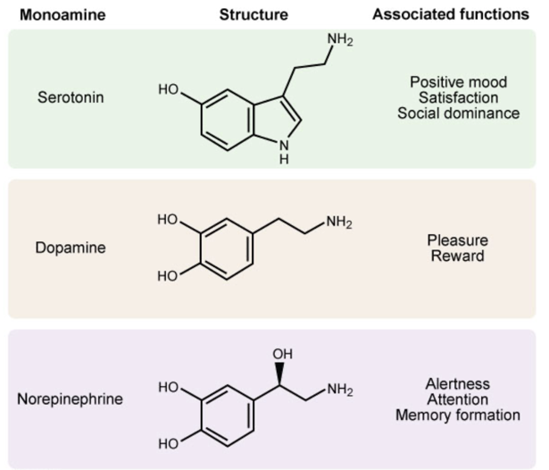  
  
monoamine hypothesis = biomedical model of depression. Depletion of monoamine neurotransmitters in the central nervous system directly causes depression symptoms. The monoamines (serotonin norepinephrine and dopamine) are neurotransmitters that have a single amine group in their molecular structure and are associated with emotion regulation.   
  
Kohlberg’s theory of moral development   
proposed theory of moral development in 6 stages.   
pre-conventional stage: mortality is externally controlled by punishment (stage1) and reciprocity with others (stage 2). At the conventional level, mortality is based on conforming to norms (stage 3) and obeying the law (stage 4). At the post conventional level, which few people achieve, morality is based on a social contract (stage 5) and personal code of ethics (stage6).

James Marcia - Identity development theory:   
evaluates the psychological progress of individuals based on their level of commitment and degree of exploration over 4 stages.  
  
identify diffusion (low commitment, low exploration)= people at this level lack direction, have not explored options and have not committed to a particular career path or future.   
  
identiy foreclosure (high commitment, low exploration) = people at this level have accepted an identity that they have been assigned (usually by parent or authority figure) without contemplation or exploration.

Identity moratorium (low commitment, high exploration)= people are this level are still trying new activities and thinking about a career path but not arrived at a decision.

Identity achievement (high commitment, high exploration) = people at this level have explored their options and are typically feel confident about who they are an what they want to do in the future.   
  
sampling bias is the result of nonrandom study techniques (eg conventional sampling) that produce nonrepresentative samples from which conclusion about the larger population cannot be drawn.   
  
Escape learning occurs when an organism learns how to terminate an ongoing unpleasant stimulus. A  
  
Avoidance learning occurs when an organism learns how to prevent coming into contact with an unpleasant stimulus before it occurs.   
  
Major personality theories   
Perspective= behavior is the result of   
psychoanalytic = unconscious conflicts between impulses a& social restraints  
trait= consistent & enduring personality depositions   
humanistic = inner drive toward growth & self – actualization  
behavioral = learning from the environment   
social cognitive= cognitive expectation, social learning/ modeling  
biological = genetic predispositions, brain structure/ function, evolution   
  
somatic symptom and related disorders (SSRDs) are a group of disorders in which bodily (somatic) symptoms or illness are associated with psychological factors. Eg Somatic symptom disorder (SSD) is an SSRD characterized by extreme distress and concern regarding one of more actual bodily / physical symptoms (eg, fatigue , pain).

counterbalancing = used to control for the potential effects that the order of intervention administration may have on the results. Eg if participants were given different interventions, A and B, a counterbalancing measure would involve separating participants into two groups, group A receiving intervention A first and the other group receiving intervention B first.   
  
psychoanalytic theory (freud)   
personality results form the interaction between the id, ego, and superego.

The id is selfish, compelling us to seek pleasure and avoid pain.

The ego is realistic, compelling us to behave in ways that are socially acceptable, and acts as a mediator between the id and superego.

The superego is moralistic and idealistic, compelling us toward perfection   
  
take away: personality change is possible when a person has a strong ego that can successfully mediate between one’s impulsive. Pleasure seeking id and the goals of the idealistic superego.   
  
cognitive behavioral therapy – replaces negative thought patterns and destructive behaviors with healthy, positive thought and behaviors.   
  
intelligence is the ability to learn, apply, adapt and reason.   
  
fluid intelligence involves logic and creativity   
  
crystalized intelligence involves knowledge and skills   
  
attention is the ability to filter certain stimuli and focus on others.   
  
selective attention is focusing on one stimulus or task   
  
divided attention is focusing on more than one stimulus.   
  
memory retrieval involves recall, recognition and relearning.   
  
recall is the retrieval of previously learned information without a prompt (free recall) or with ah prompt (cued recall) and can be subdivided into immediate recall and delayed recall. Recognition involves identifying information that one has already been exposed to. Relearning involves re-encoding information that was previously learned but forgotten.   
  
Erik Erikson’s psychosocial theory of personality development includes 8 stages that represent the human life span. Each stage Is associated with an age-related crisis which is an opportunity for individual growth and social development. Resolution does not necessarily occur in each stag before an individual moves onto the next (unresolved conflict forms the basis for adult psychopathology and other maladaptive behaviors.)   
  
trust vs. mistrust: infants (0-1 years) Infants with sensitive and attentive caregivers develop a sense of trust. Infants with inconsistent care develop mistrust.   
  
Autonomy vs. shame/doubt: toddlers (1-3 years) toddlers who are encouraged will develop independence; those who are scolded for failure will feel shame.  
  
initiative vs. guilt: children (3-6 years) who successfully interact with others will develop a sense of initiative; those who are critizsed will experience guilt.   
  
industry vs. inferiority: children (6-12 years) who successfully develop new skills will feel industrious; those who are not encouraged will feel inferior.   
  
identity vs. role confusion: adolescents (12-20 years) who successfully interact with peers develop a sense of self-identity; those who do not, experience role confusion.

Intimacy vs. isolation: adults (40-65 years) who successfully contribute to society feel productive; those who do not feel stagnant  
  
integrity vs. despair: older adults (>65 years) who feel accomplished gain a sense of integrity; those who do not feel depressed and hopeless.   
  
as aging occurs episodic, flashbulb, and source memory decline.  
  
semantic and procedural memory remains stable as aging occurs.  
  
  
contex-dependent memory refers to the physical environment in which the original learning took place or the original memory was encoded.   
  
foot-in-the-door phenomenon predicts that people are more likely to comply with a big request after they have already complied with a small request.   
  
elaboration likelihood model has 2 routes:  
  
the central route – focusing on the logical content of the message is most effective when the audience is motivated by the message  
  
peripheral route (focusing on superficial characteristics of the message is more effective when people are not motivated by the message.

Cognitive dissonance theory – people are motivated to think and behave in ways that are cognitively consistent. Divergent thoughts and or behaviors result in discomfort, motivating individuals to change their behavior and or attitudes so that they align.  
  
cognitive biases are irrational ways of thinking that impact thoughs and behavior.  
  
optimism bias is a cognitive bias where by people tend to underestimate the likelihood that bad things (eg. Cancner) will happen to them,   
  
genralized anxiety disorder (GAD) is an anxiety disorder characterized by excessive and uncontrollable worry about a range of events. People with GAD may experience muscle tension, difficulty concentrating or sleeping, and restlessness fatigue or irratibility.   
  
personality disorders are characterized by infelexible and enduring patters of thoughts, feelings, and behaviors differing markedly from social norms. Personality disorders are stable over time and across enviornments and cuase significant distress or impairment of functioning.   
  
social constructionism is a sociological theory suggesting that “reality: is created though interactions, resulting in agreed-on shared meanings.( social constructs) eg gender are defined and maintained throught the process of social interaction.